HTML project

**Name:Joseph Naeem Abdel Messih**

**S.N: 1088**

**Groub: 2**

**Section: 12**

Github link: https://github.com/Joseph-Naeem/html-project-report.com

Computer Architecture.

It is one of the main important topics to talk about, because it teaches the components of the computer and how to use it.

**Github link:**

<https://github.com/Joseph-Naeem/html-project-report.com>

project link:

<https://joseph-naeem.github.io/html-project-report.com>

**Description :**

Computer architecture is one of the most important topics to talk about, it rappresents the components of the computer and what are the different types of systems that can be used to operate the computer.

It explains also what are the input/output units and the types of the storage units.

In this web site we will know the meaning of computer architecture and what are the different units that we find using the computer, we will also illustrate the different types of systems of the computer.

**Screenshots:** 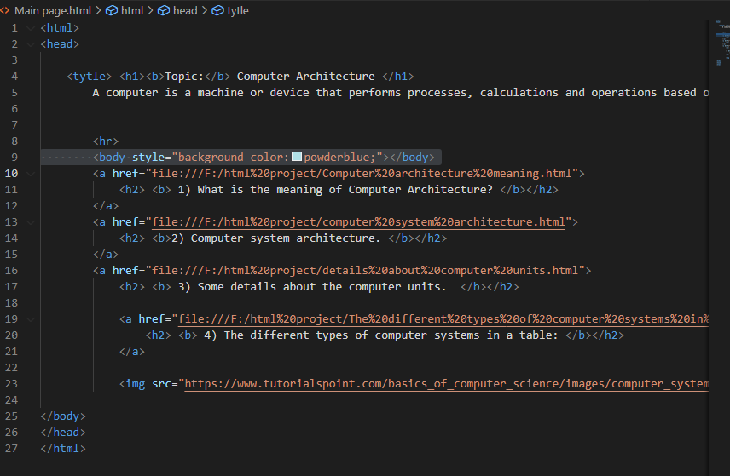

Pic.1.1 Part of the website source code (index)

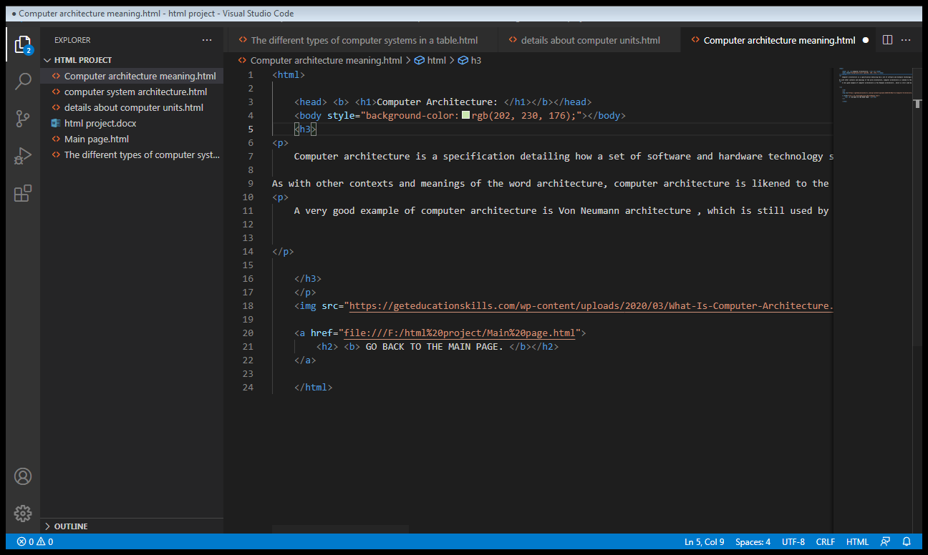

Pic.1.2. Part of the website source code (the meaning of computer architecture)

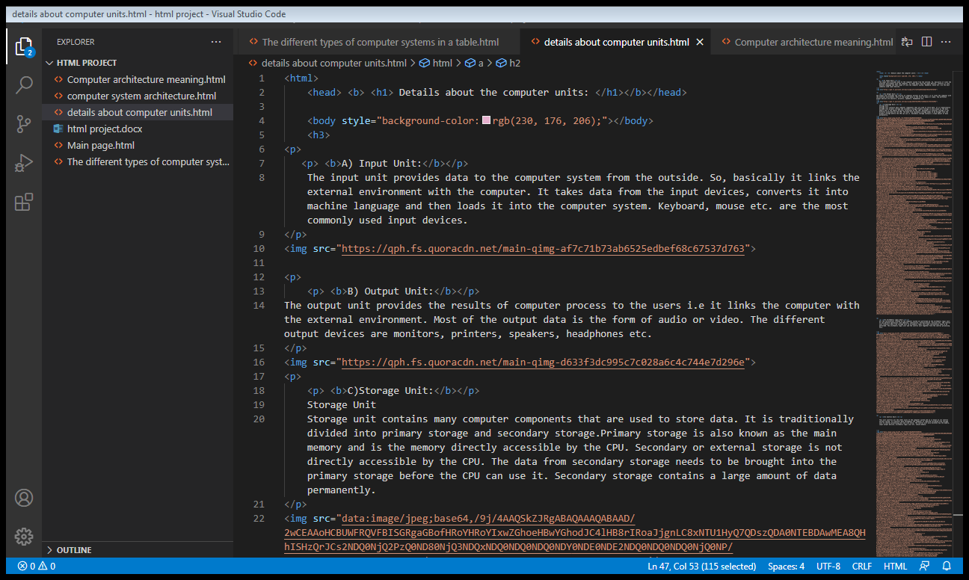 Pic.1.3. Part of the website source code (Some details about computer units)

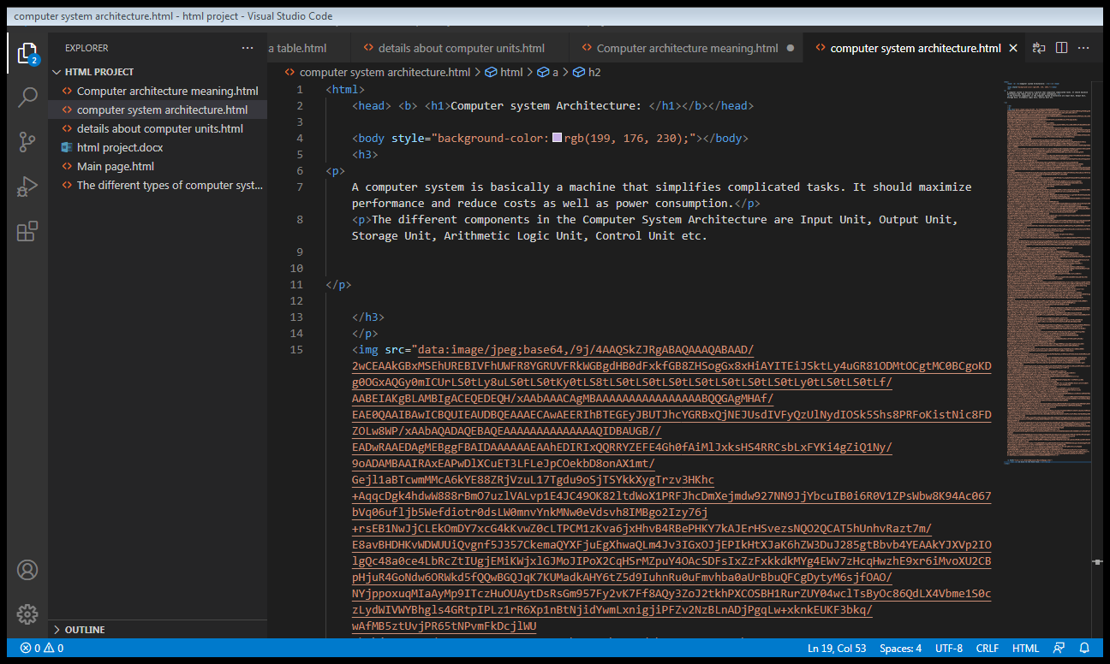 Pic.1.4. Part of the website source code (Computer system architecture)

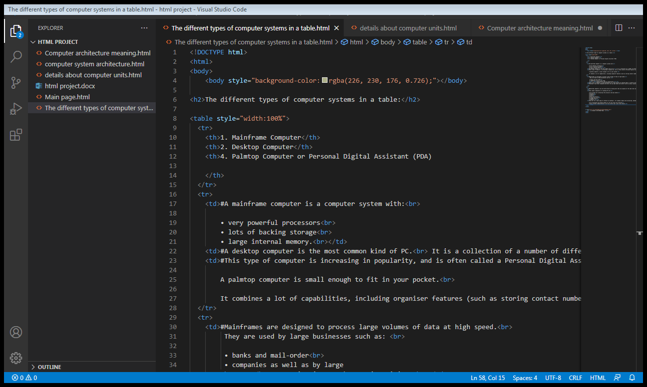

Pic.1.5. Part of the website source code (The different type of computer systems)

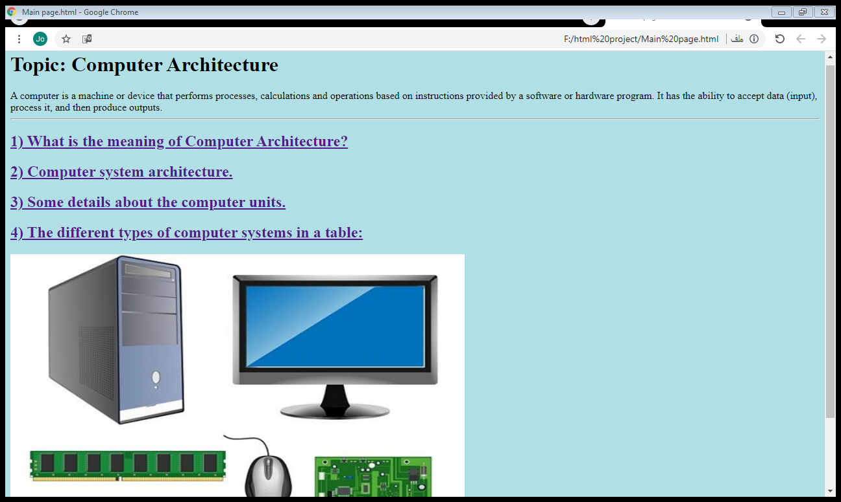

Pic.1.6. The main page of the website.

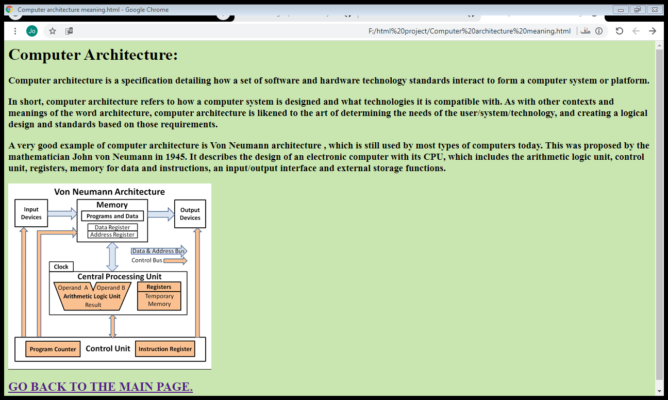

Pic.1.7. Definition of computer architecture page.

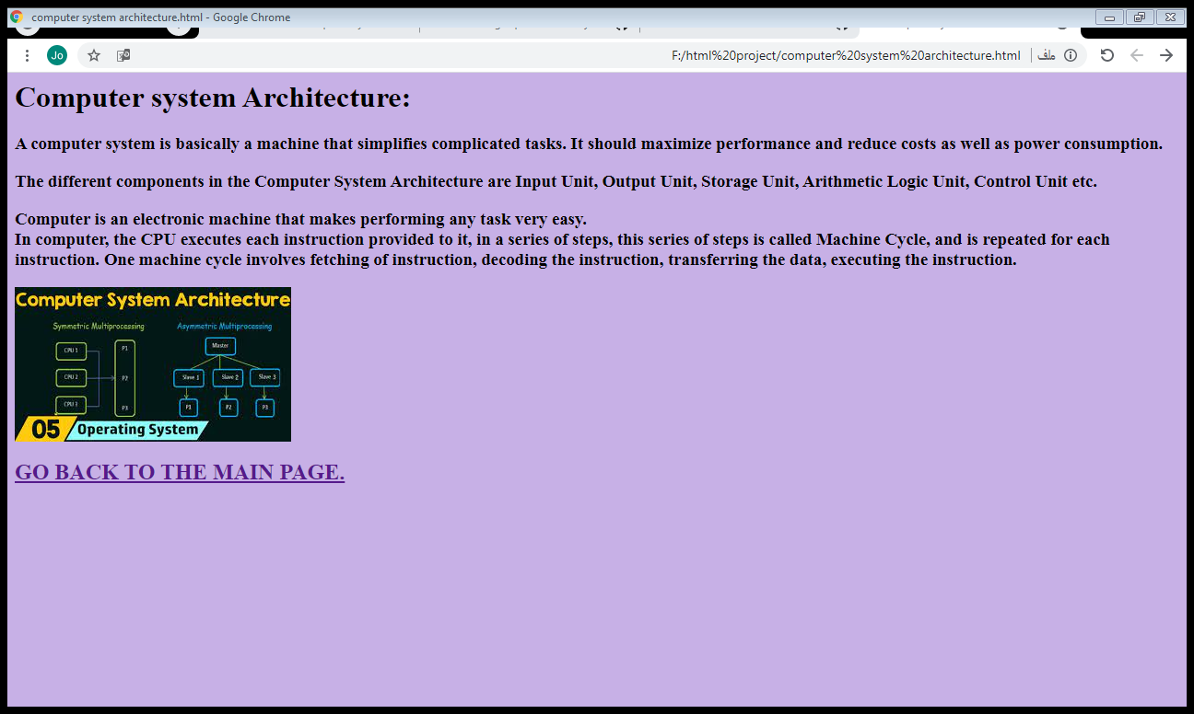 Pic.1.8. What is the computer system architecture..